Aim: Perform FFT and IFFT on Discrete Time Signals.
Theory:
FFT: Fast Fourier Transform
The Fast Fourier Transform (FFT) is an efficient algorithm used to calculate the Discrete Fourier Transform (DFT) of a discrete-time signal. It converts a signal from the time domain to the frequency domain.
In the time domain, we see how the signal changes with time or sample number. In the frequency domain, we can identify the different frequency components present in the signal.
The DFT is given by:
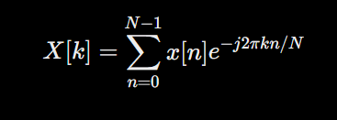
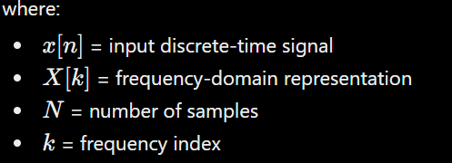
FFT performs the same mathematical operation as DFT but uses a much more efficient computational approach. This makes FFT widely used in digital signal processing, audio processing, image processing, communication systems, and frequency analysis.

IFFT: Inverse Fast Fourier Transform
The Inverse Fast Fourier Transform (IFFT) is used to convert a signal from the frequency domain back to the time domain.
The inverse transformation is given by:
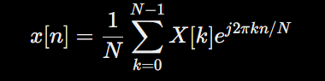
Thus, FFT and IFFT work in opposite directions:
Time Domain → FFT → Frequency Domain
Frequency Domain → IFFT → Time Domain
The IFFT is particularly useful when we want to reconstruct the original signal after analyzing or modifying its frequency components.

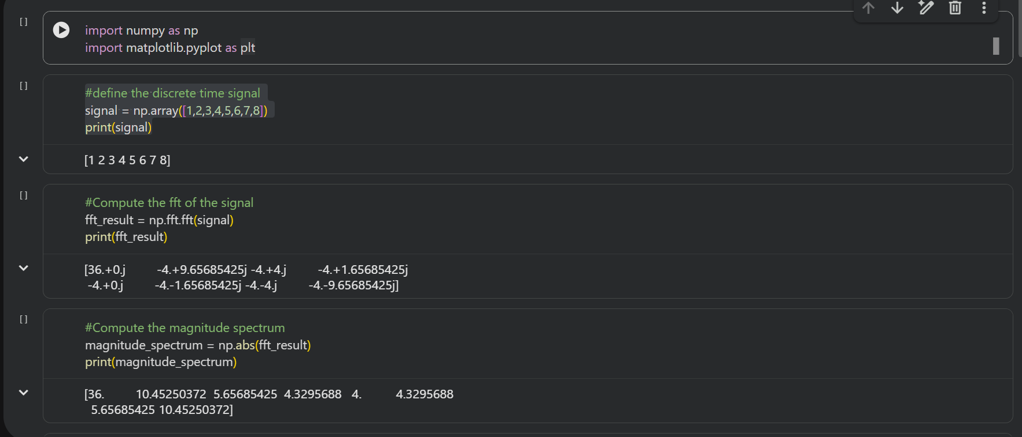
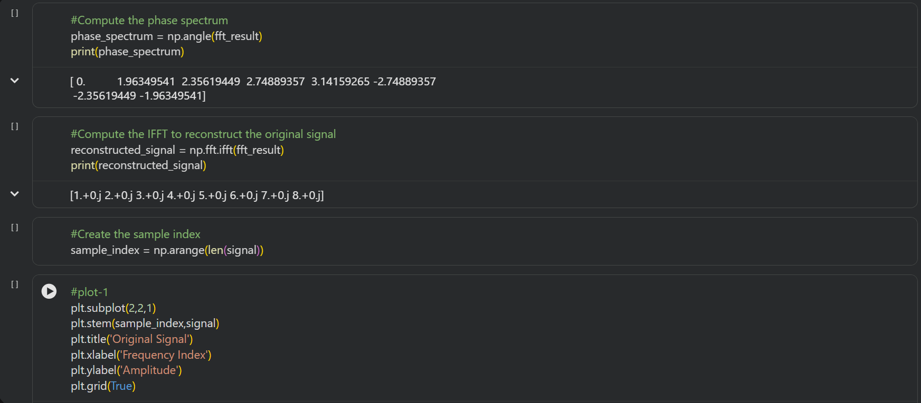
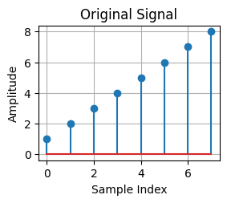
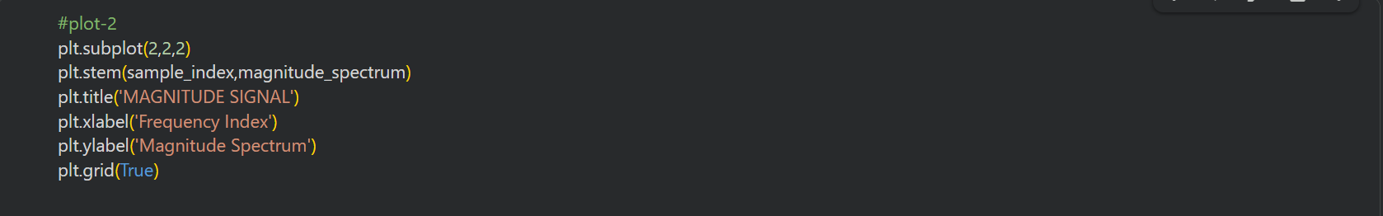
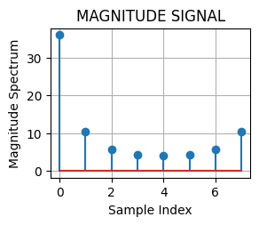
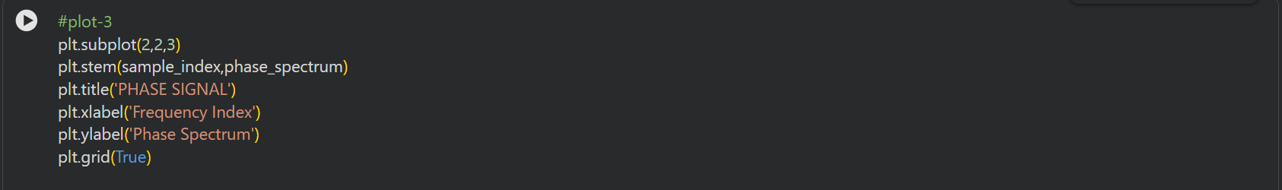
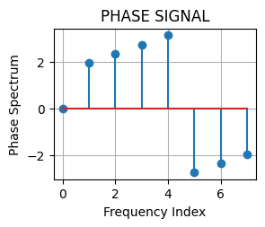
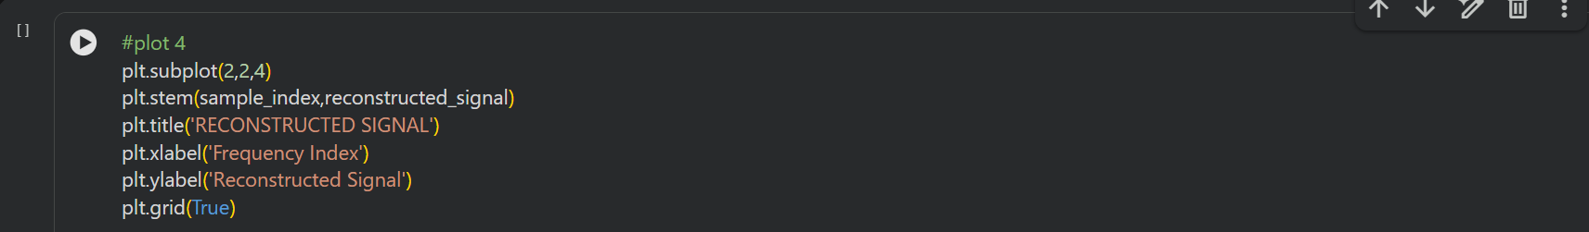
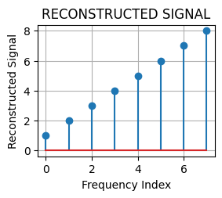

Conclusion:
In this experiment, we successfully performed FFT and IFFT on discrete-time signals and understood how a signal can be converted between the time and frequency domains. The experiment helped us understand the practical use of FFT for analysing the frequency components of a signal and IFFT for reconstructing the original signal. Overall, it gave us a better understanding of frequency-domain signal processing.

Github Link: https://github.com/divaparekh06/Digital-Signal-And-Image-Processing.git

